**CREDIT CARD FRAUD DETECTION**

|  |  |
| --- | --- |
| **Student Name** | **Ruchi Tandel (122022040501055)** |
| **Enrollment No.** | **Dev Ray (12202040501069)** |

**Objectives :**

The primary objective of this project is to design and implement a robust, scalable, and intelligent machine learning system capable of detecting fraudulent credit card transactions in real time. The system is built with the following goals:

* **Real-Time Fraud Detection**: Enable immediate analysis of each transaction as it occurs, helping financial institutions take quick action to prevent losses and protect users.
* **Model Integration**: Combine the strengths of **Random Forest** and **XGBoost** classifiers to boost detection performance, reduce false positives, and improve model reliability.
* **Advanced Feature Engineering**: Apply geospatial analysis—like calculating the distance between cardholder and merchant—to identify abnormal behavior and enhance model accuracy.
* **Effective Data Preprocessing**: Use encoding techniques (label encoding, one-hot encoding) and handle data challenges such as missing values and class imbalance, ensuring consistency across features.
* **Scalability and Adaptability**: Build a system that can manage high volumes of transaction data and adapt to evolving fraud trends through regular model evaluation and updates.
* **User-Friendly Streamlit Interface**: Develop an interactive web app that allows users to input transaction details and receive instant predictions, with clear output and intuitive design.
* **Decision Support Tool**: Support financial institutions by providing actionable insights and helping prioritize which transactions to review, making fraud investigations more efficient.

**Dataset Used :**

**Dataset Name**: Credit Card Transactions Dataset

**Source**: https://drive.google.com/file/d/1118Jwzj51KpXd0T5jiebn9ykCygwbkhn/view

**Description**:

The dataset contains historical credit card transactions with labeled outcomes (fraudulent or legitimate). It includes various features such as transaction amount, time of transaction, merchant details, and geolocation data.

**Preprocessing Steps**:

* Handling missing values and outliers
* Encoding categorical variables using label encoders and one-hot encoding
* Feature scaling and alignment to the expected model input format

**Model Chosen :**

**Random Forest Classifier**

* Ensemble Method: Combines multiple decision trees to improve accuracy and reduce overfitting.
* Robustness & Interpretability: Handles numerous features effectively and provides insights through feature importance scores.
* Hyperparameter Tuning: Parameters such as tree depth and number can be adjusted to optimize performance.

**XGBoost Classifier**

* Gradient Boosting: Sequentially builds trees to correct previous errors, resulting in high accuracy.
* Efficiency: Optimized for speed and scalability, making it suitable for real-time fraud detection.
* Built-in Handling: Manages missing data and reduces overfitting through regularization techniques.

**Performance Metrics :**

To evaluate models effectively, we used several key performance metrics:

* **Accuracy**:  
  Measures the overall proportion of correct predictions. It provides a general sense of model performance but may be misleading in cases of class imbalance.
* **Precision**:  
  Indicates the fraction of correctly identified fraudulent transactions out of all transactions flagged as fraud. High precision means fewer false positives, which is critical in reducing unnecessary alerts and investigations.
* **Recall (Sensitivity)**:  
  Reflects the proportion of actual fraudulent transactions that the model successfully detects. High recall minimizes false negatives, ensuring that most fraudulent cases are caught.
* **F1-Score**:  
  The harmonic mean of precision and recall. This metric provides a balanced measure, especially useful when dealing with imbalanced datasets, by combining both false positives and false negatives into one number.
* **AUC (Area Under the ROC Curve)**:  
  Evaluates the model's ability to differentiate between fraudulent and legitimate transactions across various threshold settings. A higher AUC indicates better overall model discrimination.

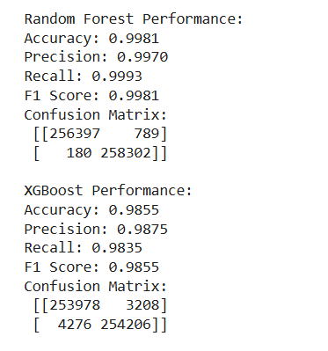

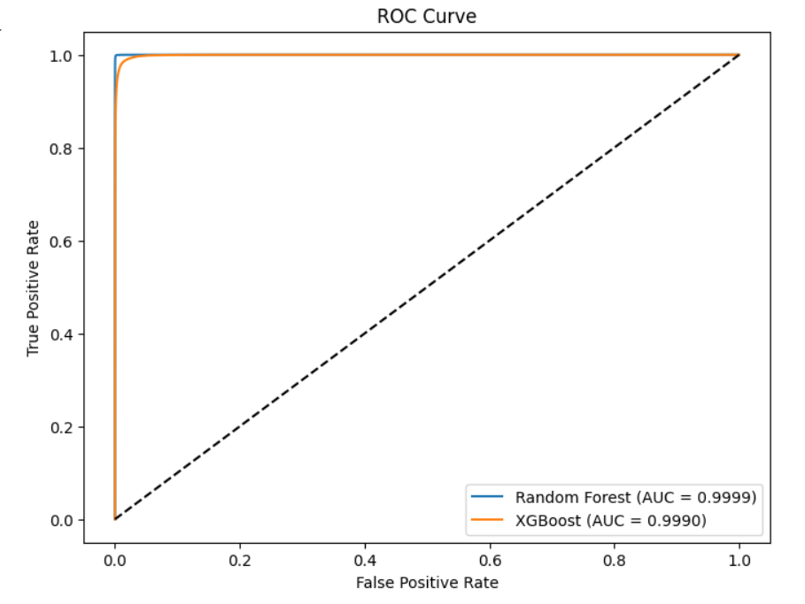

**Challenges & Learnings :**

**Challenges**

* Data Imbalance: The dataset is highly imbalanced, with fraudulent transactions being a minority. This required special techniques like oversampling or using evaluation metrics that better reflect the performance on the minority class.
* Feature Engineering: Creating meaningful features from the raw data, such as calculating the geographical distance between cardholder and merchant, was challenging but proved crucial for the detection process.
* Model Integration: Combining predictions from multiple models (Random Forest and XGBoost) and ensuring the input feature order consistency added complexity to the deployment pipeline.
* Real-Time Prediction: Ensuring that the system can provide real-time fraud predictions while maintaining high accuracy and low latency.

**Learnings**

* Preprocessing Importance: Proper data cleaning, encoding, and feature alignment are fundamental for model performance.
* Model Comparison: Testing multiple models provided insights into the strengths and weaknesses of different approaches.
* Deployment: Using Streamlit for a user-friendly interface demonstrated how powerful visualization and interactivity can be integrated with machine learning models.
* Error Handling: Building robust error-handling mechanisms and validating input data are essential steps in creating a production-ready system.

